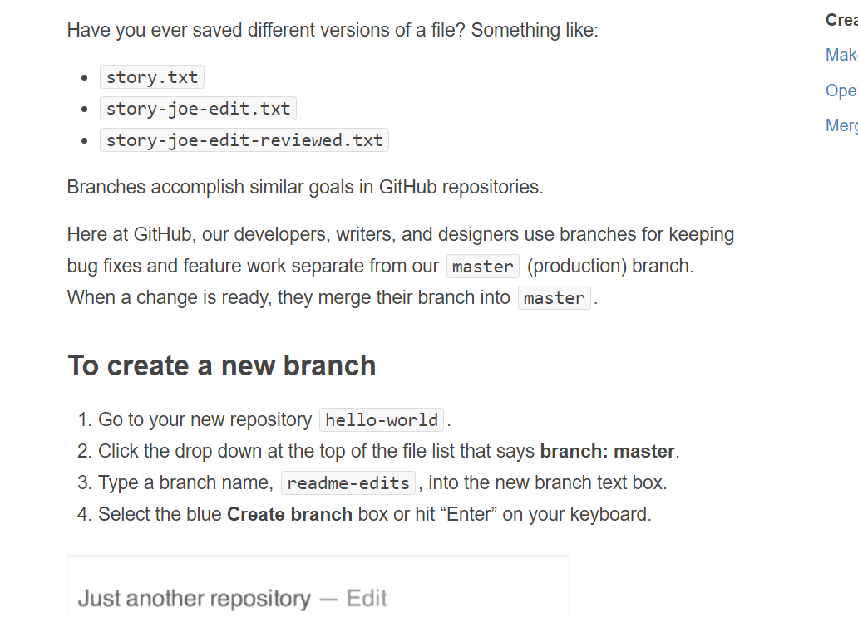

Knec;ewbc;DCJ d